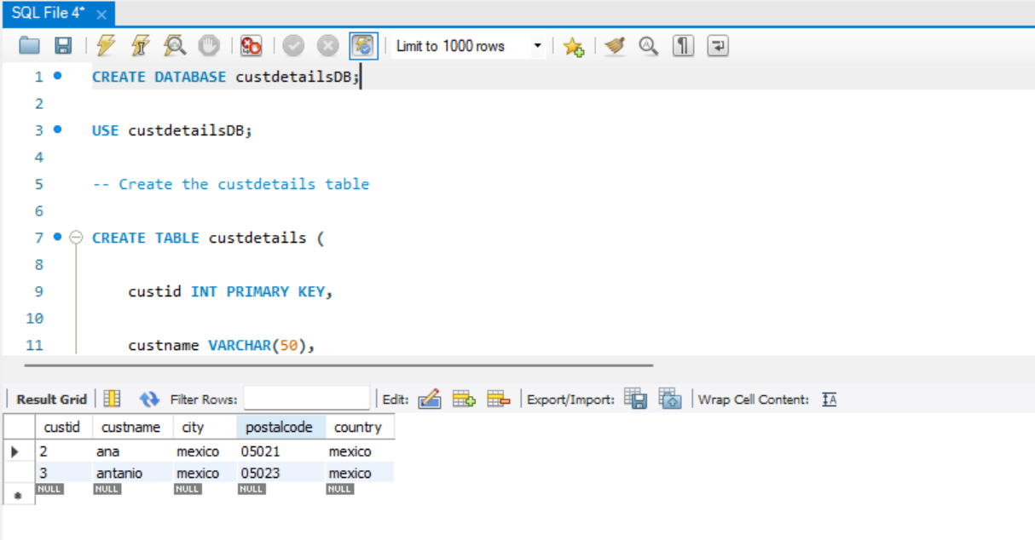

CREATE DATABASE custdetailsDB;

USE custdetailsDB;

-- Create the custdetails table

CREATE TABLE custdetails (

custid INT PRIMARY KEY,

custname VARCHAR(50),

city VARCHAR(50),

postalcode VARCHAR(20),

country VARCHAR(50)

);

-- Insert the records

INSERT INTO custdetails (custid, custname, city, postalcode, country)

VALUES

(1, 'alfred', 'berlin', '12209', 'Germany'),

(2, 'ana', 'mexico', '05021', 'mexico'),

(3, 'antanio', 'mexico', '05023', 'mexico'),

(4, 'harry', 'london', 'WA11DP', 'UK'),

(5, 'sierra', 'lulea', 'S95822', 'sweden');

-- Query 1: Print all records of customers from country Mexico

SELECT \*

FROM custdetails

WHERE country = 'mexico';

-- Query 2: Print all records of customers in ascending order of countries

SELECT \*

FROM custdetails

ORDER BY country ASC;

-- Query 3: Print count of records for customers from country Mexico (use GROUP BY and HAVING)

SELECT country, COUNT(\*) AS count

FROM custdetails

GROUP BY country

HAVING country = 'mexico';

-- Query 4: Print all records in descending order having more than 1 entry from the same country

SELECT \*

FROM custdetails

WHERE country IN (

SELECT country

FROM custdetails

GROUP BY country

HAVING COUNT(\*) > 1

)

ORDER BY country DESC;